Measures of Dispersion

Dispersion: Dispersion is an important characteristic of a frequency distribution. It tells us how the individual values are distributed around the average.

Measures of Dispersion: Following are the measures of dispersion:

- Absolute measures
- Range
- Mean deviation
- Standard deviation
- Quartile deviation

- Relative measures
- Coefficient of range
- Coefficient of mean deviation
- Coefficient of variation
- Coefficient of quartile deviation

Range: The range is the simplest measure of dispersion. This is defined as the difference between the highest and lowest values in a data set.
(Ungrouped data)
(Grouped data), where is lower limit of the first class and is the upper limit of the last class.

Mean Deviation: Let be n observations of a variable with mean, then mean deviation is defined as:
(Ungrouped data)
(Grouped data), where be the mid-values and be their corresponding frequencies.

Standard deviation: Let be n observations of a variable with mean, then standard deviation is defined as
(Ungrouped data)
(Grouped data), where be the mid-values and be their corresponding frequencies.

Variance: The square of the standard deviation is the variance.
(Ungrouped data)
(Grouped data)

Quartile deviation: If Q₁ is the first quartile and Q₃ is third quartile, then the quartile deviation is defined as:

Coefficient of Variation:

The coefficient of variation is defined by: , where s is the standard deviation and is the mean.

If we want to compare the variability of two or more series, we can use this method. The series or groups of data for which the coefficient of variation is greater, indicates that the group is more variable, less stable, less uniform, less consistent or less homogeneous. On the other hand, if the coefficient of variation is less, it indicates that the group is less variable, more stable, more uniform, more consistent or more homogeneous.

Skewness and Kurtosis: Skewness and Kurtosis are known as the shape characteristics of a frequency distribution, because they throw light on the shape of a distribution. Skewness is the degree of asymmetry, or departure from symmetry, of a distribution. The degree of peakness or flatness of a distribution relative to a normal distribution is called kurtosis.

Measure of skewness and kurtosis: The measure of skewness is given by where, and
In a skewed distribution, when the curve has a longer tail to the right side, then the distribution is said to be positively skewed and in the reverse case the distribution is said to be negatively skewed.
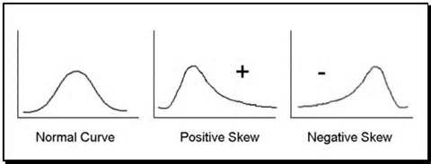

The measure of kurtosis is given by where, and There are three types of kurtosis.
If the value of is greater than 3, the curve is more peaked than symmetric curve that is leptokurtic.
If the value of is less than 3, the curve is less peaked than symmetric curve that is platykurtic. If the value of is equal to 3, the curve is then symmetric curve and it is mesokurtic.

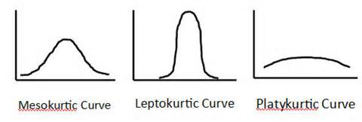

Exercise 1: Do the exercise give in the class which is related to find the range, mean deviation, standard deviation and variance for ungrouped data.

Exercise 2: Do the exercise give in the class which is related to find the range, mean deviation, standard deviation and variance for grouped data.

Exercise 3: See the example which is done in the class related to coefficient of variation for two series.

